INN HOTELS Group
Business Report

Coded Project
By
Rajesh Mambulli

Table of Contents
Coded Project 1
1. Context 8
2. Objective 8
3. Data Description 8
4. Data Overview through Python 10
4.1 Checking for missing values in the data. 11
4.2 Checking for duplicate values in the data. 11
4.3 Checking the statistical summary of the numerical data. 12
5.0 Univariate Analysis 14
5.1 Observations on no_of_adults 14
5.2 Observations on no_of_children 15
5.3 Observations on no_of_weekend_nights 15
5.4 Observations on no_of_week_nights 16
5.5 Observations on required_car_parking_space 16
5.6 Observations on lead_time 17
5.7 Observations on arrival_year 18
5.8 Observations on arrival_month 18
5.9 Observations on arrival_date 19
5.10 Observations on repeated_guest 20
5.11 Observations on no_of_previous_cancellations 20
5.12 Observations on no_of_previous_bookings_not_canceled 21
5.13 Observations on avg_price_per_room 21
5.14 Observations on market_segment_type 22
5.15 Observations on no_of_special_requests 23
5.16 Observations on booking_status 23
6.0 Bivariate Analysis 24
6.1 Observations on booking_status vs no_of_special_requests 25
6.2 Observations on booking_status vs no_of_previous_cancellations 26
6.3 Observations on booking_status vs avg_price_per_room 27
6.4 Observations on booking_status vs market_segment_type 28
6.5 Observations on booking_status vs lead_time 29
6.6 Observations on booking_status vs room_type_reserved 30
6.7 Observations on booking_status vs repeated_guest 31
6.8 Observations on booking_status vs required_car_parking_space 32
6.9 Observations on booking_status vs type_of_meal_plan 33
6.10 Observations on avg_price_per_room vs market_segment_type 34
7.0 Finding Outliers 35
8.0 Data Preparation for modelling 36
8.1 Scaling the Data 36
8.2 Logistic Regression (with Statsmodel) 37
8.3 Naive - Bayes Classifier 39
8.4 KNN Classifier (K = 3) 40
8.5 Decision Tree Classifier 41
9.0 Model Performance Improvement 43
9.1 Dealing with high p-value variables 45
9.2 Training the Logistic Regression model again with only the significant features 46
9.3 Determining optimal threshold using ROC Curve 47
9.4 Checking tuned Logistic Regression model performance on training set. 47
9.5 Checking tuned Logistic Regression model performance on test set. 48
9.6 KNN Classifier (different values of K) 49
9.7 Checking tuned KNN model performance on training set. 49
9.8 Checking tuned KNN model performance on test set. 50
9.9 Decision Tree Classifier (pre-pruning) 50
9.10 Checking tuned Decision Tree Classifier performance on training set 50
9.11 Checking tuned Decision Tree Classifier performance on test set 51
9.12 Visualizing the Decision Tree 52
9.12 Analysing Feature Importance for tuned Decision Tree Classifier 52
10.0 Model Performance Comparison and Final Model Selection 53
11.0 Actionable Insights and Recommendations 53
12.0 Answers to EDA questions 56
1. What are the busiest months in the hotel? 56
2. Which market segment do most of the guests come from? 57
3. Hotel rates are dynamic and change according to demand and customer demographics. What are the differences in room prices in different market segments? 58
4. What percentage of bookings are cancelled? 59
5. Repeating guests are the guests who stay in the hotel often and are important to brand equity. What percentage of repeating guests cancel? 60
6.0 Many guests have special requirements when booking a hotel room. Do these requirements affect booking cancellation? 61

Table of Figures

Figure 1: Top 5 Rows of Dataset 10
Figure 2: DataTypes in the dataset 10
Figure 3: Missing values in Attributes 11
Figure 4: Duplicate values check 11
Figure 5: Statistical Summary of the numerical data 12
Figure 6: Observations on No.of adults 14
Figure 7: Observations on No of Children 15
Figure 8: Observations on no_of_weekend_nights 15
Figure 9: Observations on no_of_week_nights 16
Figure 10: Observations on required_car_parking_space 16
Figure 11: Observations on lead_time 17
Figure 12: Observations on arrival_year 18
Figure 13: Observations on arrival_month 18
Figure 14: Observations on arrival_date 19
Figure 15: Observations on repeated_guest 20
Figure 16: Observations on no_of_previous_cancellations 20
Figure 17: Observations on no_of_previous_bookings_not_canceled 21
Figure 18: Observations on avg_price_per_room 21
Figure 19: Observations on market_segment_type 22
Figure 20: Observations on no_of_special_requests 23
Figure 21: Observations on booking_status 23
Figure 22: Correlation heat map b/w variables 24
Figure 23: Observations on booking_status vs no_of_special_requests 25
Figure 24: Observations on booking_status vs no_of_previous_cancellations 26
Figure 25: Observations on booking_status vs avg_price_per_room 27
Figure 26: Observations on booking_status vs market_segment_type 28
Figure 27: Observations on booking_status vs lead_time 29
Figure 28: Observations on booking_status vs room_type_reserved 30
Figure 29: Observations on booking_status vs repeated_guest 31
Figure 30: Observations on booking_status vs required_car_parking_space 32
Figure 31: Observations on booking_status vs type_of_meal_plan 33
Figure 32: Observations on avg_price_per_room vs market_segment_type 34
Figure 33: Boxplot of Outliers 35
Figure 34: Top 5 Rows of Scaled Train data 36
Figure 35: Top 5 Rows of Scaled Test data 36
Figure 36: Logistic Regression (with Statsmodel) 37
Figure 37: Performance of model on Training set 37
Figure 38: Confusion Matrix 38
Figure 39: Performance of model on test set 38
Figure 40: Confusion matrix 38
Figure 41: Performance of model on train data 39
Figure 42: Confusion matrix 39
Figure 43: Performance of model on test set 39
Figure 44: Confusion matrix 40
Figure 45: Performance of model on training set 40
Figure 46: Confusion Matrix 40
Figure 47: Performance on test set 41
Figure 48: Confusion Matrix 41
Figure 49: Performance of model on training set 41
Figure 50: Confusion matrix 42
Figure 51: Performance of model on test set 42
Figure 52: Confusion matrix 42
Figure 53: Attributes 43
Figure 54: Dropped Attribute 43
Figure 55: Attributes and their VIFs 44
Figure 56: P-value of the variables 45
Figure 57: Significant variables 45
Figure 58: Logistic model summary after tuning 46
Figure 59: ROC Curve 47
Figure 60: Optimal Threshold 47
Figure 61: Performance of Logistic Regression model on Training set 47
Figure 62:Confusion Matrix 48
Figure 63: Performance of tuned model on test set 48
Figure 64: Confusion matrix 48
Figure 65: KNN Classifier with different K values 49
Figure 66: Model performance on train set 49
Figure 67: Confusion matrix 49
Figure 68: Model performance on test set 50
Figure 69: Confusion Matrix 50
Figure 70: Model performance on train set 50
Figure 71: Confusion Matrix 51
Figure 72: Model Performance on test set 51
Figure 73: Confusion Matrix 51
Figure 74: Visualizing the Decision Tree 52
Figure 75: Feature Importance for tuned Decision Tree Classifier 52
Figure 76: Model Performance Comparison and Final Model Selection on train set 53
Figure 77: Model Performance Comparison and Final Model Selection on test set 53

Context
A significant number of hotel bookings are called off due to cancellations or no-shows. The typical reasons for cancellations include change of plans, scheduling conflicts, etc. This is often made easier by the option to do so free of charge or preferably at a low cost which is beneficial to hotel guests but it is a less desirable and possibly revenue-diminishing factor for hotels to deal with. Such losses are particularly high on last-minute cancellations.
The new technologies involving online booking channels have dramatically changed customers’ booking possibilities and behaviour. This adds a further dimension to the challenge of how hotels handle cancellations, which are no longer limited to traditional booking and guest characteristics.
The cancellation of bookings impacts a hotel on various fronts:
- Loss of resources (revenue) when the hotel cannot resell the room.
- Additional costs of distribution channels by increasing commissions or paying for publicity to help sell these rooms.
- Lowering prices last minute, so the hotel can resell a room, resulting in reducing the profit margin.
- Human resources to make arrangements for the guests.

Objective
The increasing number of cancellations calls for a Machine Learning based solution that can help in predicting which booking is likely to be cancelled. INN Hotels Group has a chain of hotels in Portugal, they are facing problems with the high number of booking cancellations and have reached out to your firm for data-driven solutions. You as a data scientist have to analyse the data provided to find which factors have a high influence on booking cancellations, build a predictive model that can predict which booking is going to be cancelled in advance, and help in formulating profitable policies for cancellations and refunds.

Data Description
The data contains the different attributes of customers' booking details. The detailed data dictionary is given below.
Data Dictionary:
- Booking_ID: the unique identifier of each booking
- no_of_adults: Number of adults
- no_of_children: Number of Children
- no_of_weekend_nights: Number of weekend nights (Saturday or Sunday) the guest stayed or booked to stay at the hotel
- no_of_week_nights: Number of weeknights (Monday to Friday) the guest stayed or booked to stay at the hotel
- type_of_meal_plan: Type of meal plan booked by the customer:
  - Not Selected – No meal plan selected
  - Meal Plan 1 – Breakfast
  - Meal Plan 2 – Half board (breakfast and one other meal)
  - Meal Plan 3 – Full board (breakfast, lunch, and dinner)
- required_car_parking_space: Does the customer require a car parking space? (0 - No, 1- Yes)
- room_type_reserved: Type of room reserved by the customer. The values are ciphered (encoded) by INN Hotels Group
- lead_time: Number of days between the date of booking and the arrival date
- arrival_year: Year of arrival date
- arrival_month: Month of arrival date
- arrival_date: Date of the month
- market_segment_type: Market segment designation.
- repeated_guest: Is the customer a repeated guest? (0 - No, 1- Yes)
- no_of_previous_cancellations: Number of previous bookings that were cancelled by the customer prior to the current booking
- no_of_previous_bookings_not_canceled: Number of previous bookings not canceler by the customer prior to the current booking
- avg_price_per_room: Average price per day of the reservation; prices of the rooms are dynamic. (in euros)
- no_of_special_requests: Total number of special requests made by the customer (e.g. high floor, view from the room, etc)
- booking_status: Flag indicating if the booking was cancelled or not.

Data Overview through Python
Data which is stored in csv file is imported to Jupyter Notebook with the help of pandas, NumPy libraries and used matplotlib and seaborn libraries to help with data visualization. Dataset is stored in python variable named data.
Understanding the shape of the dataset.
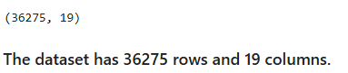
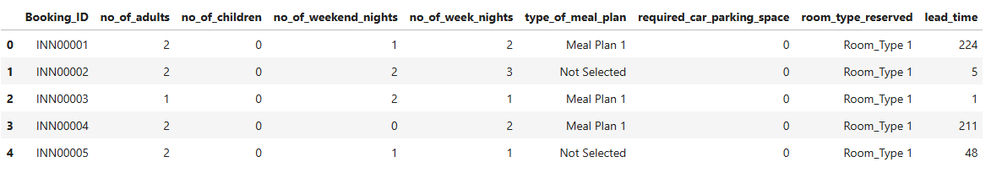
Figure 1: Top 5 Rows of Dataset

Checking the data types of data.
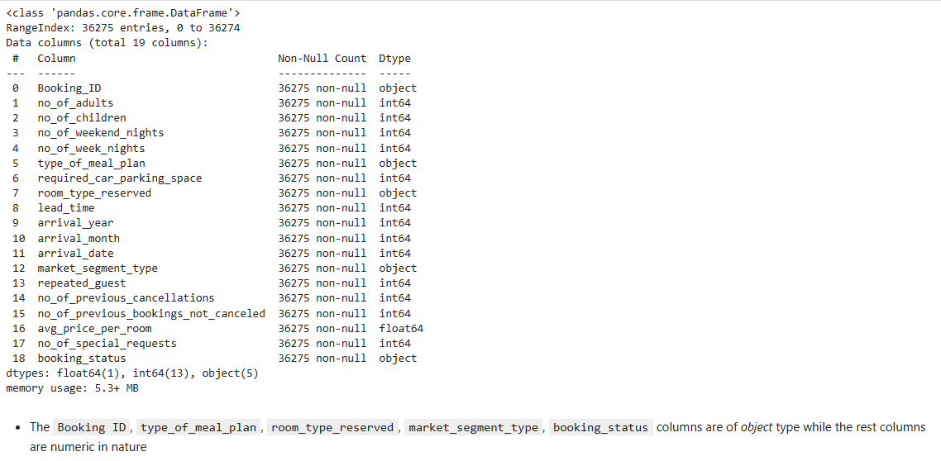
Figure 2: DataTypes in the dataset

Checking for missing values in the data.
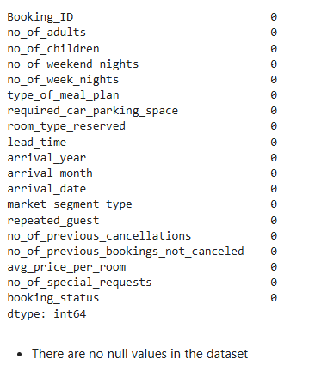
Figure 3: Missing values in Attributes

Checking for duplicate values in the data.
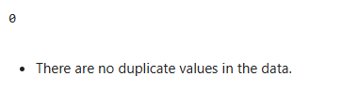
Figure 4: Duplicate values check

Checking the statistical summary of the numerical data.

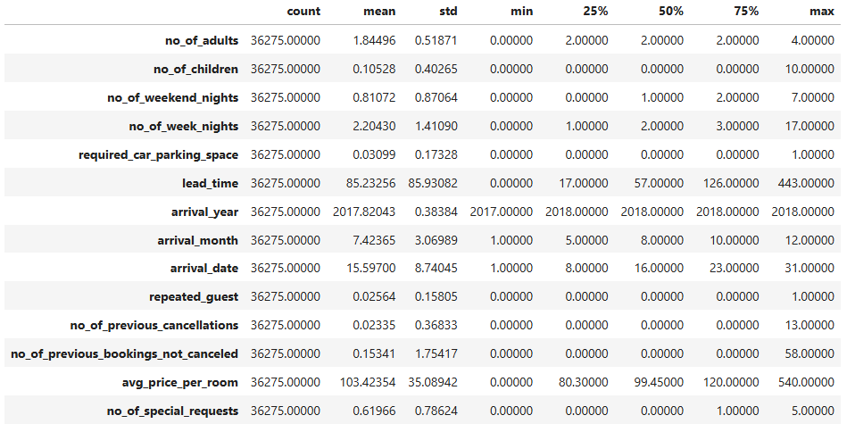
Figure 5: Statistical Summary of the numerical data
1. Number of Adults
The range varies from a minimum of 0 adults to a maximum of 4 adults per booking. Most bookings (25%, 50%, and 75%) typically involve 2 adults.
2. Number of Children
The number of children ranges from 0 to 10. A significant majority of bookings (25%, 50%, and 75%) do not include any children.
3. Number of Weekend Nights
The number of weekend nights ranges from 0 to 7. Many bookings (25%) have no weekend nights, while 50% and 75% of bookings have 1 and 2 weekend nights, respectively.
4. Number of Week Nights
The number of week nights ranges from 0 to 17. While 25% of bookings include 1 week night, 50% have 2-week nights, and 75% have 3-week nights.
5. Required Car Parking Space
The number of required parking spaces ranges from 0 to 1, with the majority of bookings (25%, 50%, and 75%) not requiring any car parking space.
6. Lead Time
The lead time ranges from 0 to 443 days. While 25% of bookings have a lead time of 17 days, 50% have a lead time of 57 days, and 75% have a lead time of 126 days.
7. Arrival Year
The arrival years range from 2017 to 2018, with 25% and 75% of bookings recorded in 2017 and 50% of bookings in 2018.
8. Arrival Month
The arrival months range from January (1) to December (12). The months of May, August, and October represent the 25th, 50th, and 75th percentiles, respectively.
9. Arrival Date
The arrival dates range from the 1st to the 31st of the month. The 8th, 16th, and 23rd days of the month represent the 25th, 50th, and 75th percentiles, respectively.
10. Repeated Guest
The number of repeated guests ranges from 0 to 1, with the majority of bookings (25%, 50%, and 75%) not involving repeated guests.
11. Number of Previous Cancellations
The number of previous cancellations ranges from 0 to 13. Most bookings (25%, 50%, and 75%) have no previous cancellations.
12. Number of Previous Bookings Not Cancelled
The number of previous bookings not cancelled ranges from 0 to 72. A significant majority of bookings (25%, 50%, and 75%) have no previous bookings not cancelled.
13. Average Price per Room
The price per room ranges from 0 to 540 units. The prices at the 25th, 50th, and 75th percentiles are 69.29, 94.50, and 126.00 units, respectively.
14. Number of Special Requests
The number of special requests ranges from 0 to 5. Many bookings (25%) have no special requests, while 50% and 75% of bookings have 0 and 1 special request, respectively.

5.0 Univariate Analysis

5.1 Observations on no_of_adults
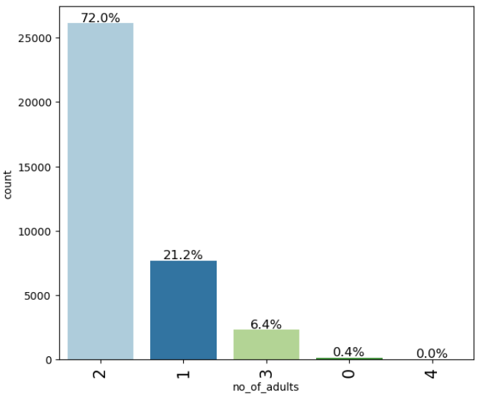
Figure 6: Observations on No.of adults
Around 72% of are of 2 adults, 21% are single adults whereas 6.4% are of 3 adults.

5.2 Observations on no_of_children
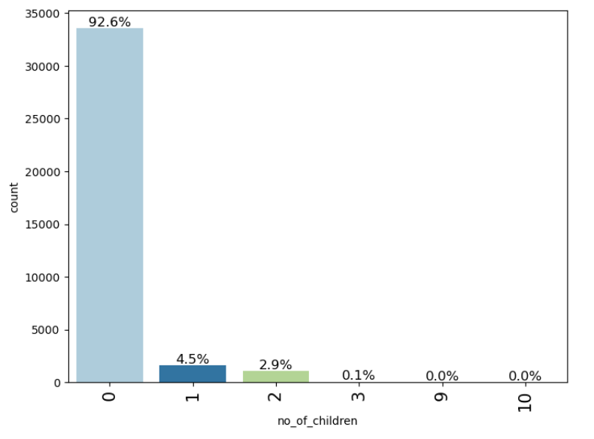
Figure 7: Observations on No of Children
- Around 92.6% of bookings are of zero children and 4.5% are of 1 child and 2.9% are of 2 children

5.3 Observations on no_of_weekend_nights
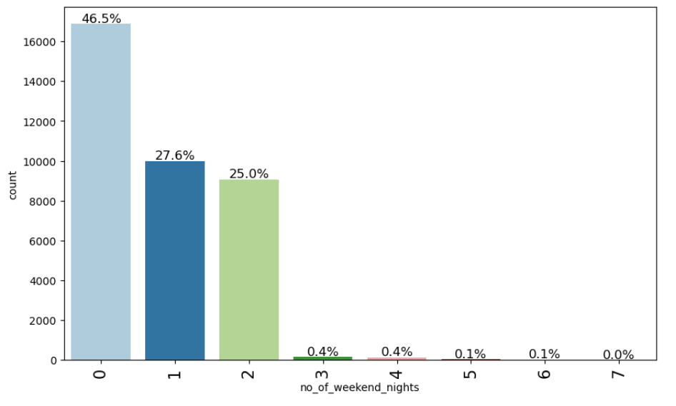
Figure 8: Observations on no_of_weekend_nights
- Most of the bookings are of 0 weekend nights and 1 and 2 stands next respectively

5.4 Observations on no_of_week_nights

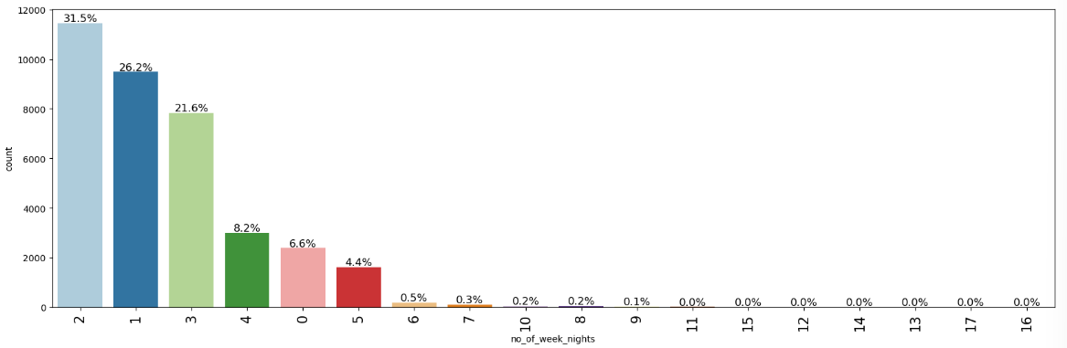
Figure 9: Observations on no_of_week_nights
- Most of the booking contains 2 weeknights at least. next is 1 and 3 and 4

5.5 Observations on required_car_parking_space

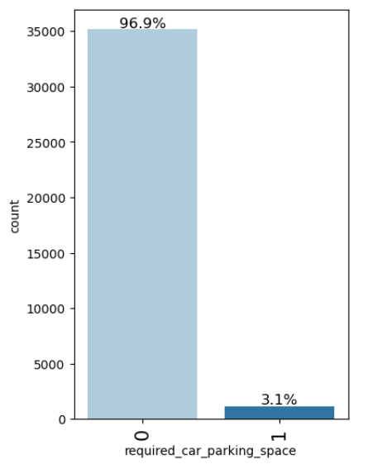
Figure 10: Observations on required_car_parking_space
- Most of the bookings 96.9% does not required car parking space.

5.6 Observations on lead_time
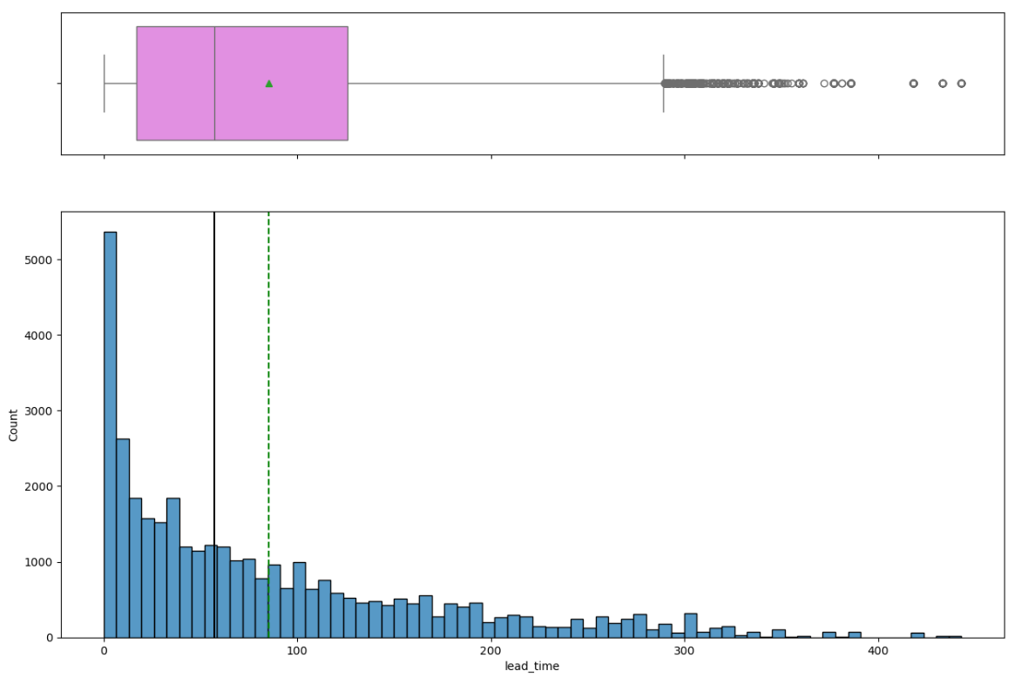
Figure 11: Observations on lead_time
- The distribution of lead_time is uniformly distributed with some higher values being less frequent.
- Outliers are present in this attribute.

5.7 Observations on arrival_year
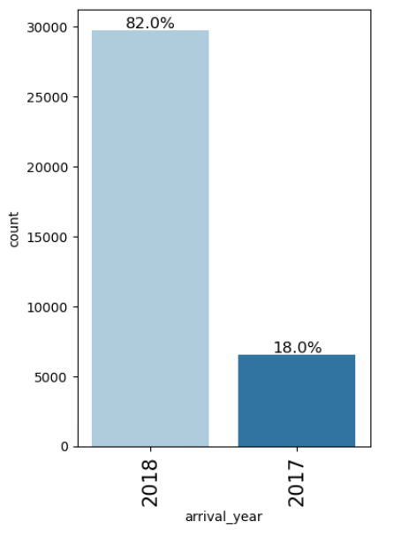
Figure 12: Observations on arrival_year
- Most of the bookings 82.0% are of year 2018

5.8 Observations on arrival_month

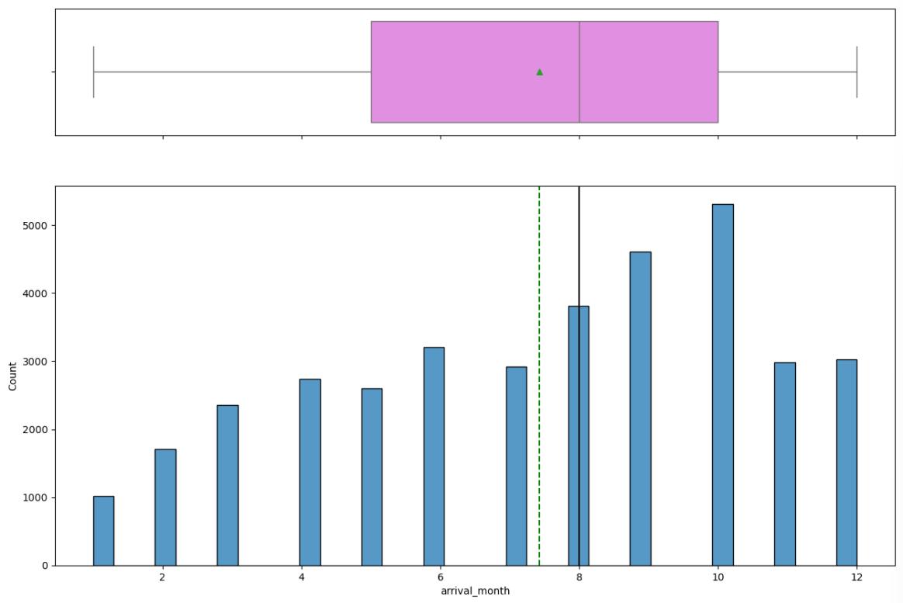
Figure 13: Observations on arrival_month
- Most of the bookings are in Month of October, September, and August.

5.9 Observations on arrival_date
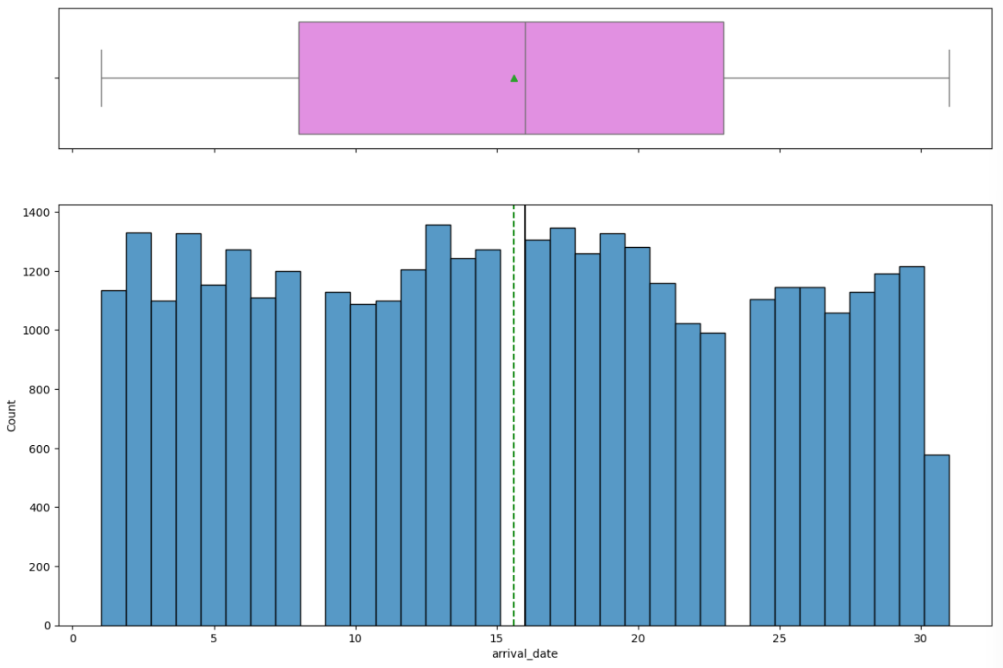
Figure 14: Observations on arrival_date
- The distribution of arrival_date is uniformly distributed
- No Outliers are present.

5.10 Observations on repeated_guest
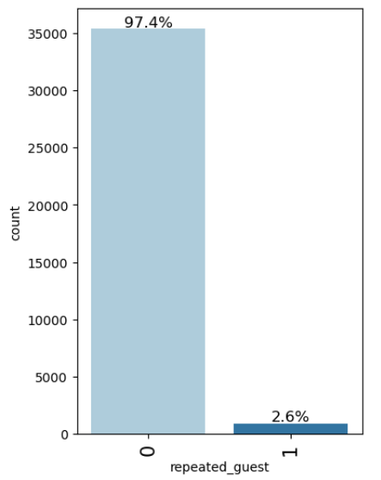
Figure 15: Observations on repeated_guest
- Most of the Bookings are First timers and and repeating guest are < 3%

5.11 Observations on no_of_previous_cancellations
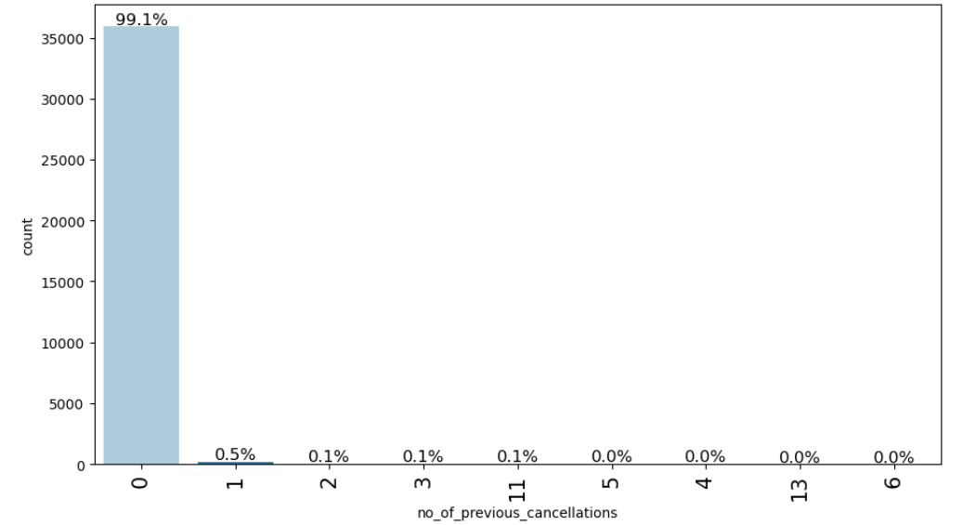
Figure 16: Observations on no_of_previous_cancellations
- Most of the Bookings 99.1% have not cancelled bookings previously.

5.12 Observations on no_of_previous_bookings_not_canceled
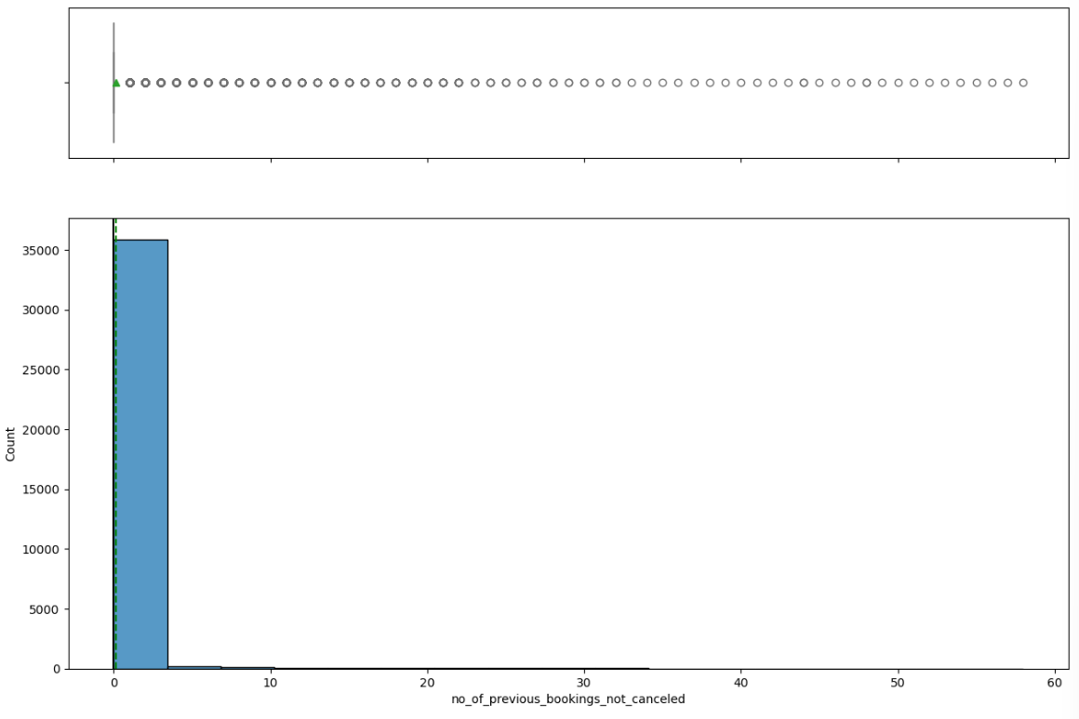
Figure 17: Observations on no_of_previous_bookings_not_canceled
- Most of the Bookings are not cancelled bookings previously.

5.13 Observations on avg_price_per_room
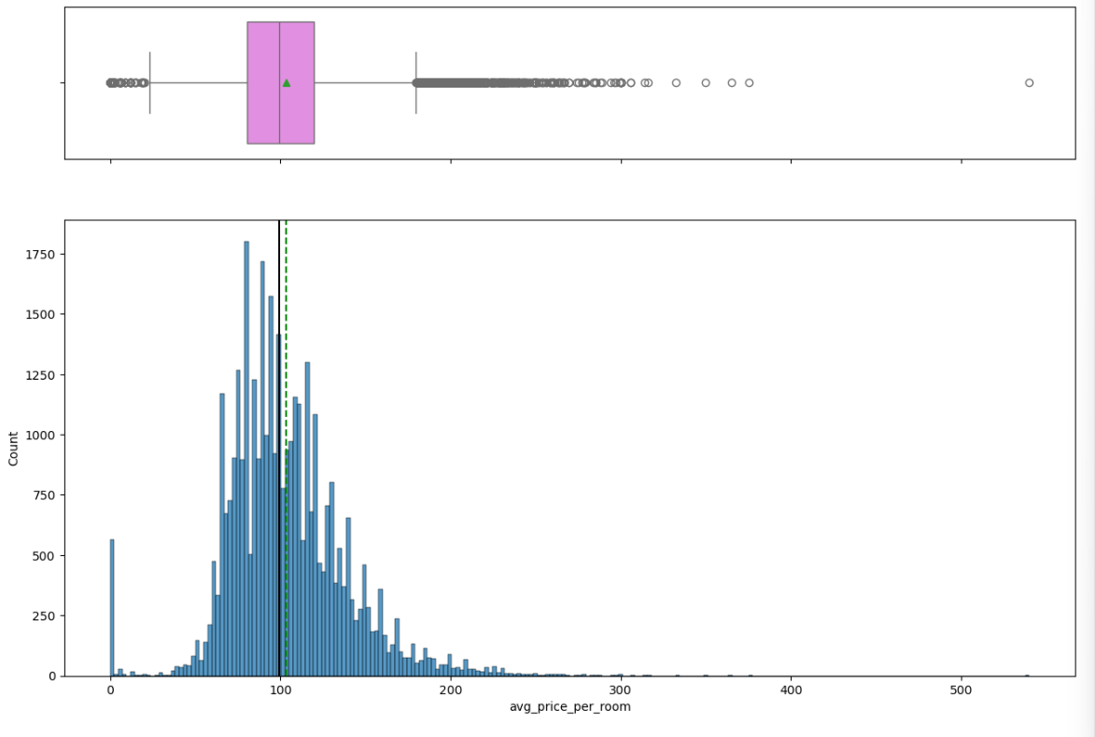
Figure 18: Observations on avg_price_per_room
- avg_price_per_room attribute data is normally distributed
- There are outliers in this attribute.

5.14 Observations on market_segment_type
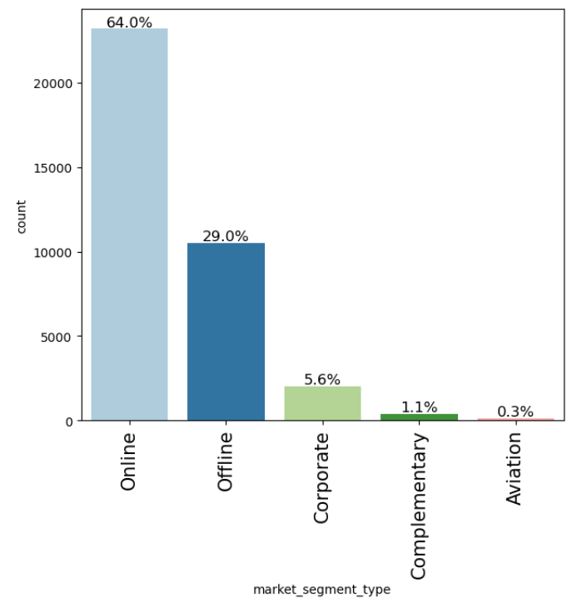
Figure 19: Observations on market_segment_type
Most of the bookings are of Online, then Offline.

5.15 Observations on no_of_special_requests
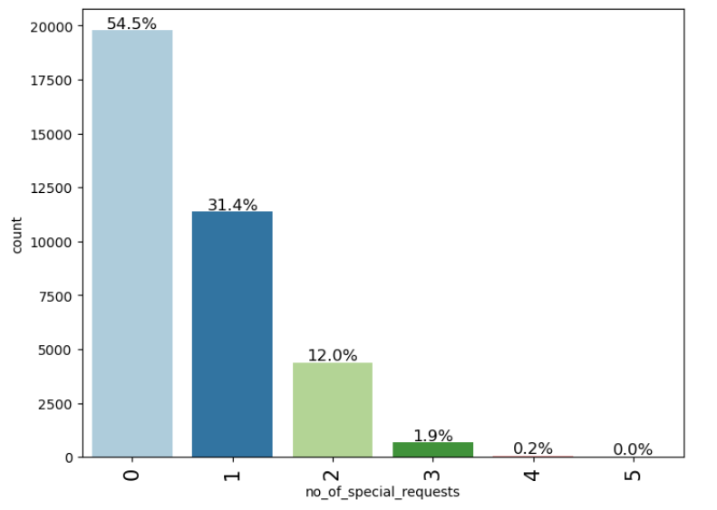
Figure 20: Observations on no_of_special_requests
- Most of the bookings are not having special requests

5.16 Observations on booking_status

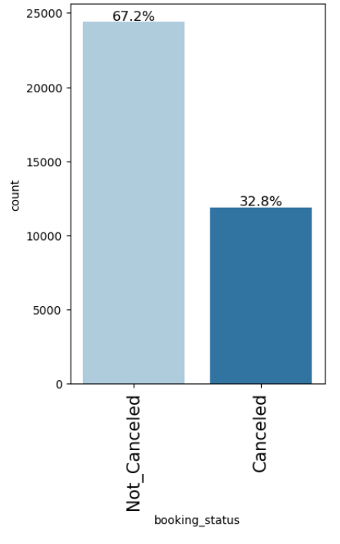
Figure 21: Observations on booking_status
- 32.8% of bookings are cancelled.

6.0 Bivariate Analysis
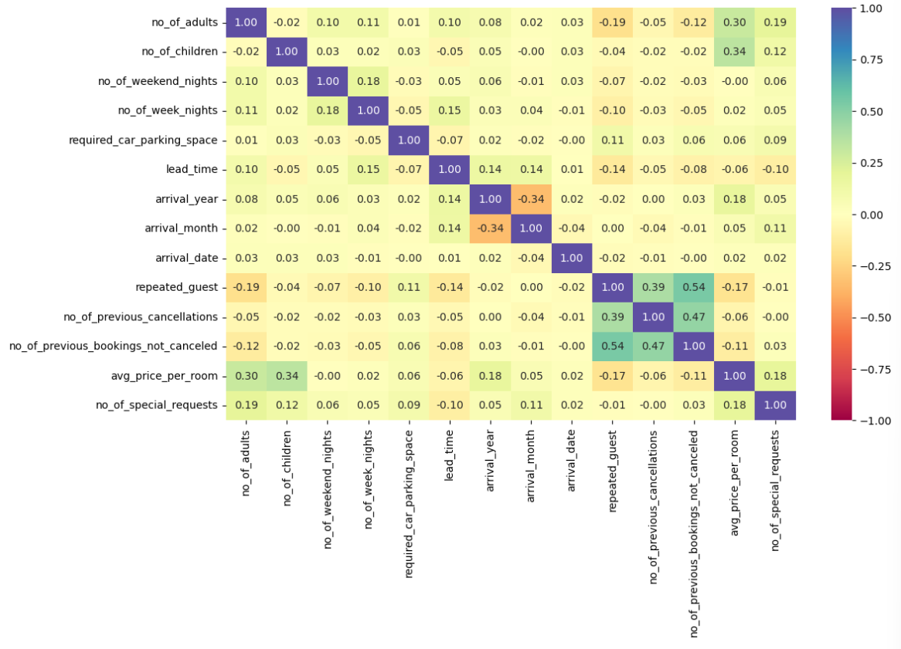
Figure 22: Correlation heat map b/w variables
- Lead Time vs. Average Price per Room: There is a moderate positive correlation between lead time and the average price per room. This suggests that bookings made further in advance tend to have higher average room prices.
- Number of Previous Cancellations vs. Lead Time: The number of previous cancellations shows a slightly positive correlation with lead time. This could indicate that guests who tend to cancel their bookings also book further in advance.
- Number of Special Requests vs. Average Price per Room: There is a slight positive correlation between the number of special requests and the average price per room. Higher spending guests might demand more special requests.
- Weekend Nights vs. Week Nights: There's a moderate positive correlation between the number of weekend nights and week nights, which could imply that guests who stay over the weekend are more likely to extend their stay into the weekdays as well.
- Number of Children vs. Number of Adults: The number of children shows a moderate positive correlation with the number of adults, which is expected as larger groups or families tend to book together.
- Required Car Parking Space vs. Number of Special Requests: There is a slight positive correlation between required car parking space and the number of special requests, indicating that guests who need parking may also have more specific needs.
- Repeated Guest: Repeated guest status shows weak correlations with most variables, suggesting that repeated bookings do not heavily influence most of the other variables like special requests or average price per room.
- Lead Time vs. Number of Special Requests: There is a slight positive correlation between lead time and the number of special requests, indicating that guests who plan further ahead are likely to have more specific needs or requests.

6.1 Observations on booking_status vs no_of_special_requests

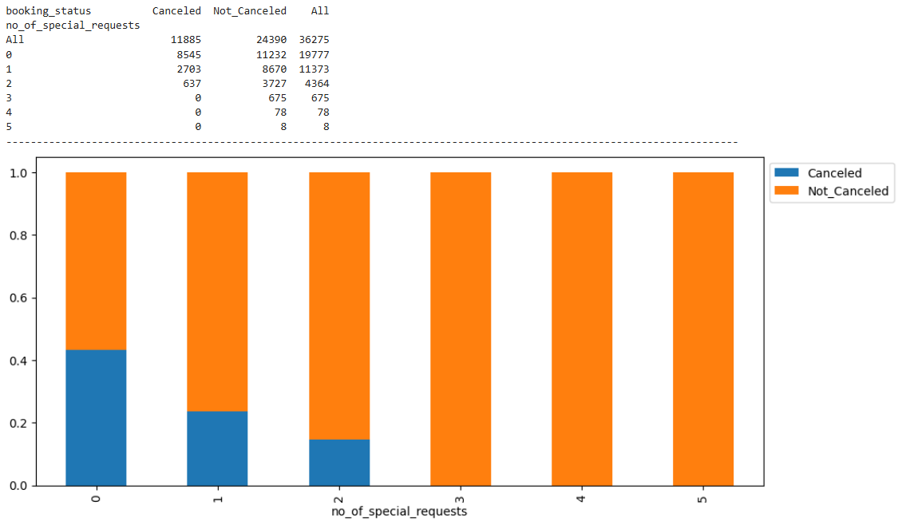
Figure 23: Observations on booking_status vs no_of_special_requests
Most of the bookings are cancelled from customers who provided 0 requests and 1 and 2 requests

6.2 Observations on booking_status vs no_of_previous_cancellations
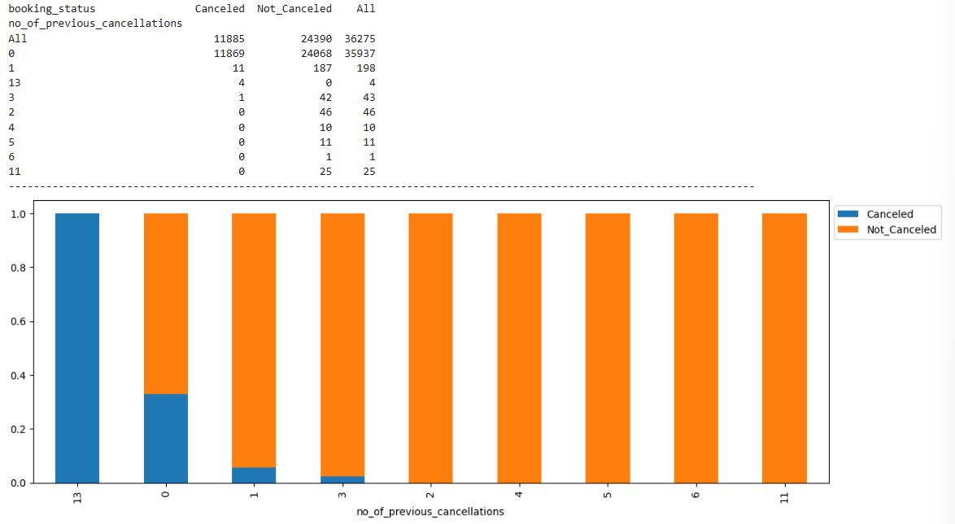
Figure 24: Observations on booking_status vs no_of_previous_cancellations
Most of the cancellations are from customers who were first time customers.

6.3 Observations on booking_status vs avg_price_per_room
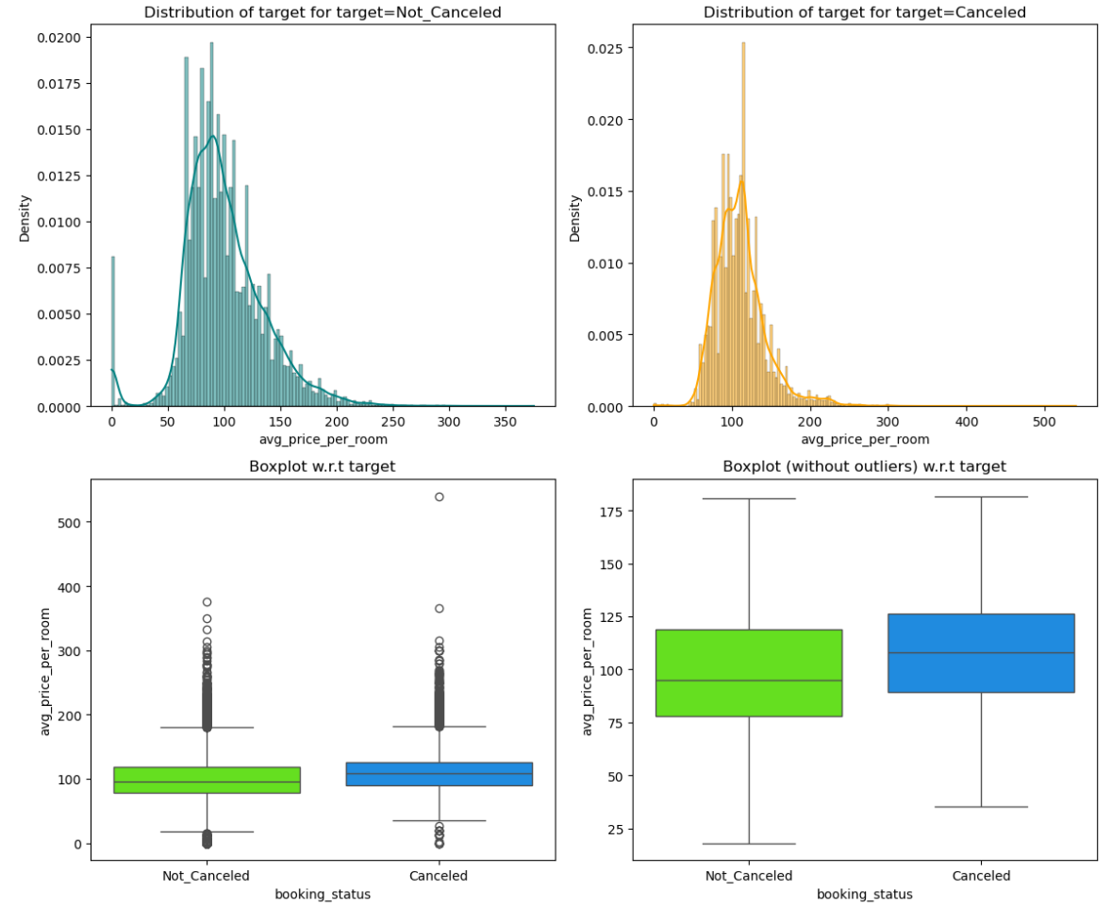
Figure 25: Observations on booking_status vs avg_price_per_room
- Bookings with an average room price between 50 and 100 are less likely to be cancelled.
- There is a broader range of prices for cancelled bookings, with a notable density between 60 and 80.
- The median average price per room is higher for not-cancelled bookings compared to cancelled ones.

6.4 Observations on booking_status vs market_segment_type

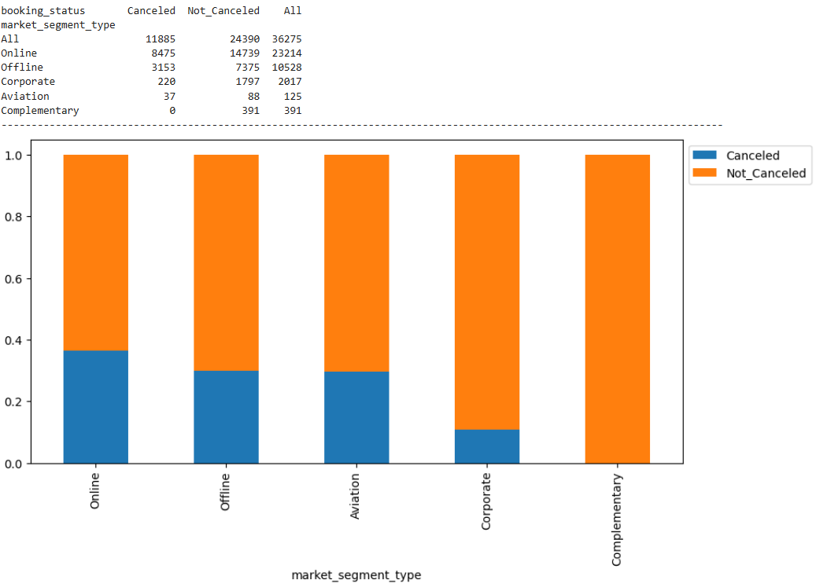
Figure 26: Observations on booking_status vs market_segment_type
- The Corporate and Offline segments have the highest proportions of not canceled bookings, indicating that these segments are more stable in terms of booking retention.
- The Online segment has the highest number of canceled bookings in absolute terms and also has a relatively high proportion of cancellations.
- The Complementary segment has no cancellations, which might suggest either a small sample size or very specific conditions that ensure bookings are not canceled.

6.5 Observations on booking_status vs lead_time
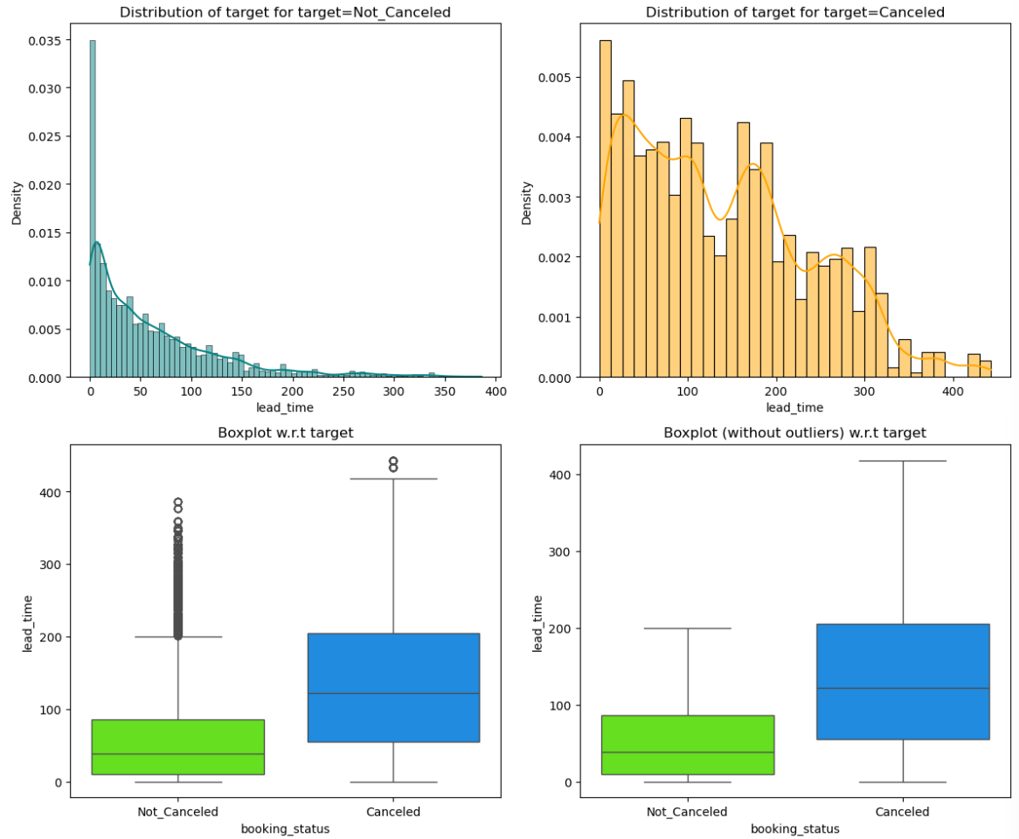
Figure 27: Observations on booking_status vs lead_time
- Shorter lead times are associated with a lower likelihood of cancellation.
- Longer lead times are associated with a higher likelihood of cancellation.

6.6 Observations on booking_status vs room_type_reserved
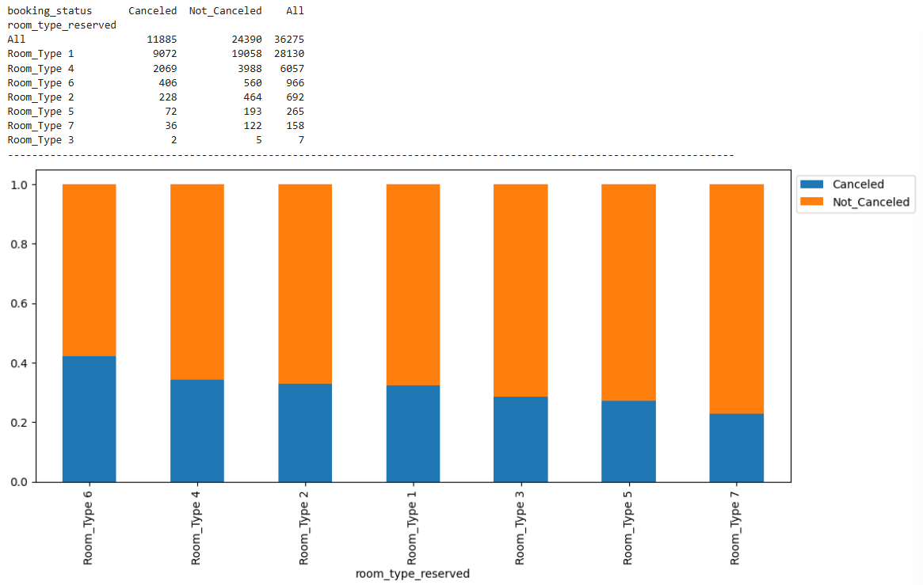
Figure 28: Observations on booking_status vs room_type_reserved

- Room_Type 1 has the highest number of total bookings and the highest number of not canceled bookings, suggesting it is the most popular room type.
- Room_Type 6 has the highest proportion of cancelled bookings, indicating a higher likelihood of cancellations for this room type.
- Room_Type 7 has the lowest proportion of cancelled bookings, suggesting higher customer satisfaction or better retention strategies for this room type.

6.7 Observations on booking_status vs repeated_guest
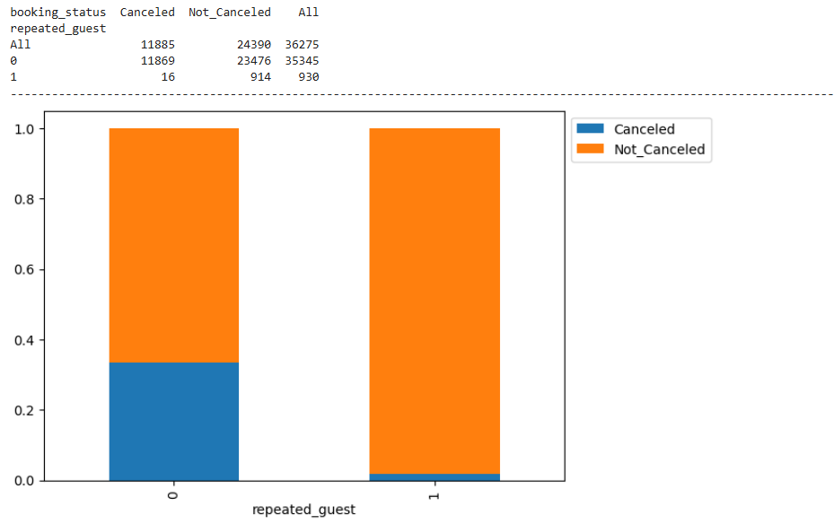
Figure 29: Observations on booking_status vs repeated_guest
- A significantly higher proportion of bookings are not cancelled for repeated guests compared to non-repeated guests.
- The overall cancellation rate is higher among non-repeated guests.

6.8 Observations on booking_status vs required_car_parking_space
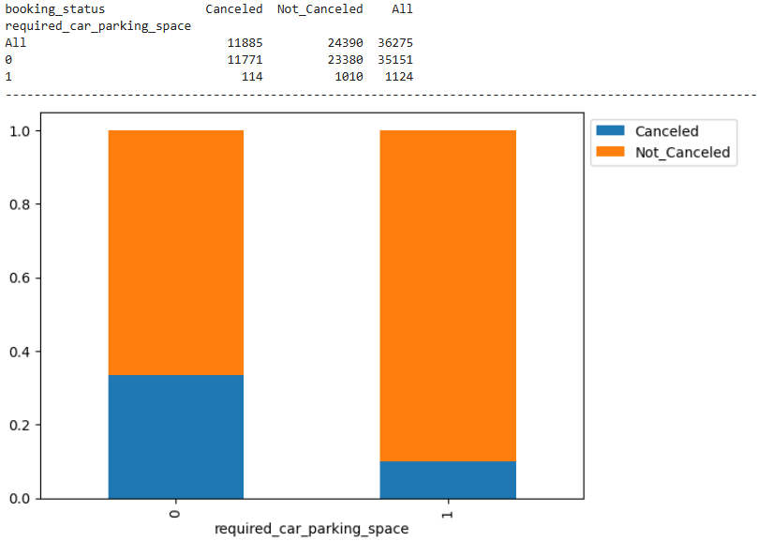
Figure 30: Observations on booking_status vs required_car_parking_space
- Bookings that required car parking space (1) have a significantly lower cancellation rate (approximately 10.1%) compared to those that did not require car parking space (approximately 33.5%).
- This suggests that customers who need car parking space are more committed to their bookings, possibly due to additional travel plans or requirements.

6.9 Observations on booking_status vs type_of_meal_plan
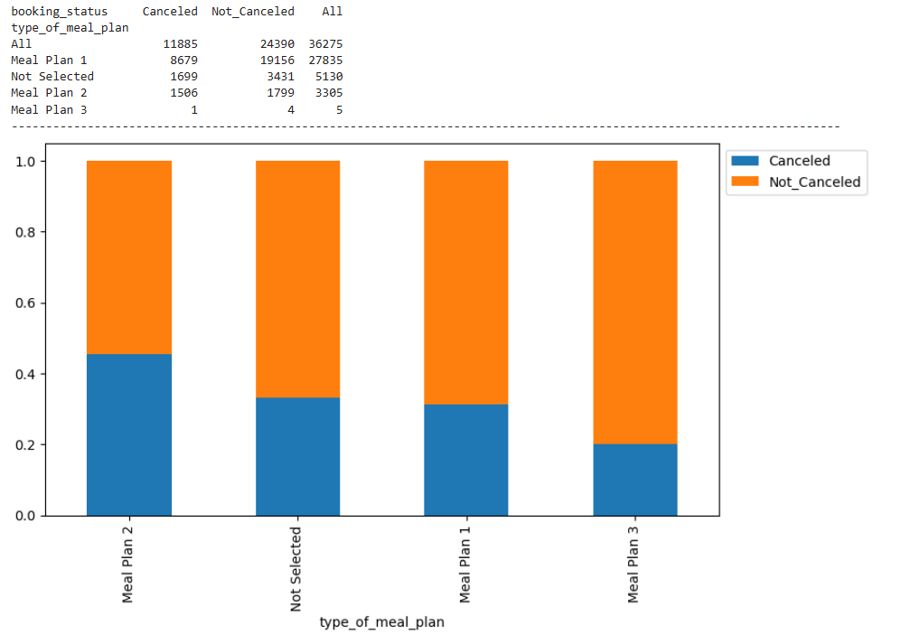
Figure 31: Observations on booking_status vs type_of_meal_plan
- Meal Plan 1 has the highest number of total bookings, both cancelled and not cancelled, suggesting it is the most popular meal plan.
- Meal Plan 3 has the lowest number of total bookings but has a high proportion of not cancelled bookings.
- The highest cancellation rate is seen in Meal Plan 2, with nearly half of the bookings being cancelled.
- The proportion of cancelled bookings is relatively consistent for Meal Plan 1 and bookings with no meal plan selected.

6.10 Observations on avg_price_per_room vs market_segment_type

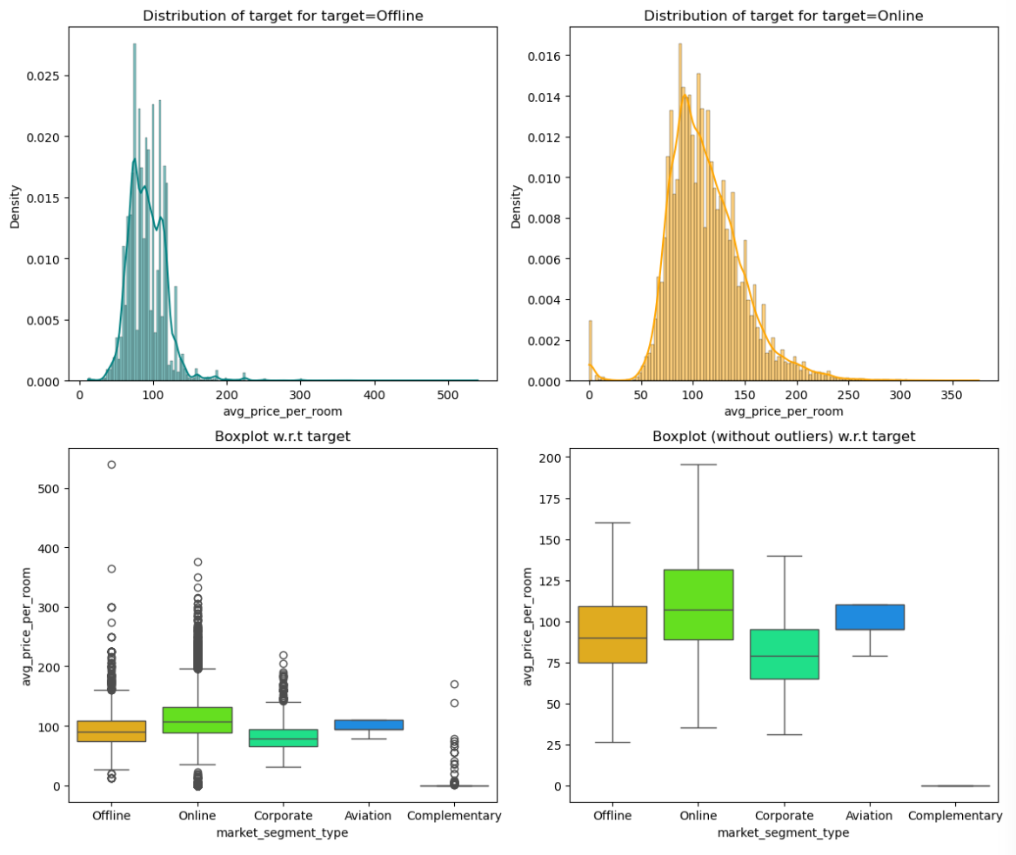
Figure 32: Observations on avg_price_per_room vs market_segment_type

- Offline bookings have a median price of 75, with most prices falling between 50 to 100.
- Online bookings have a slightly higher median price of 80, with most prices between 55 to 105.
- Corporate bookings have the highest median price of 90, indicating that this segment is willing to pay more.
- Aviation and Complementary bookings show different price ranges, with Complementary bookings having the lowest median price of 65.

7.0 Finding Outliers
Finding outliers on numerical columns.
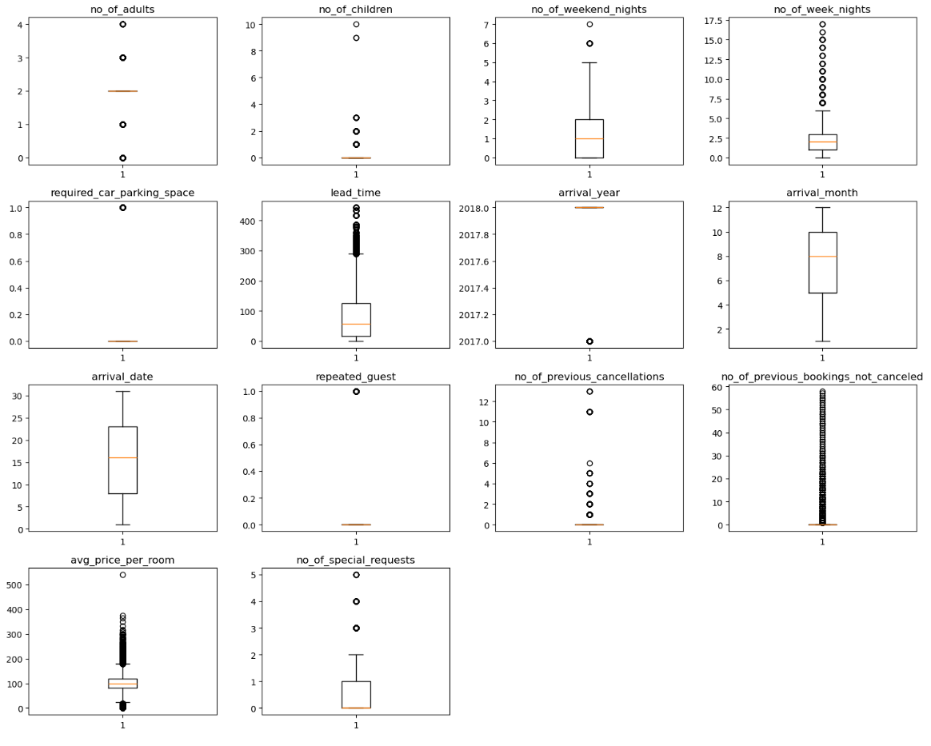
Figure 33: Boxplot of Outliers
Each of the numerical attributes contain outliers but these are real values which are true in nature in Realtime. So, treating them would be manipulating the data which in turn effects the model.

8.0 Data Preparation for modelling

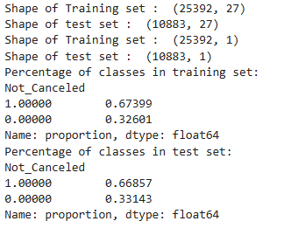

8.1 Scaling the Data
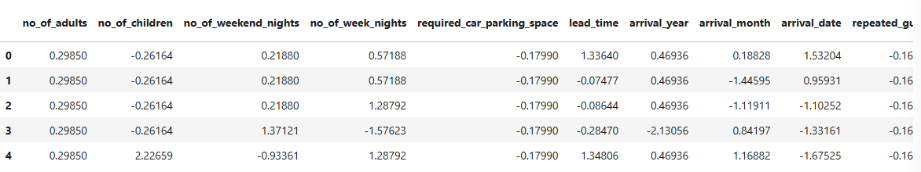
Figure 34: Top 5 Rows of Scaled Train data

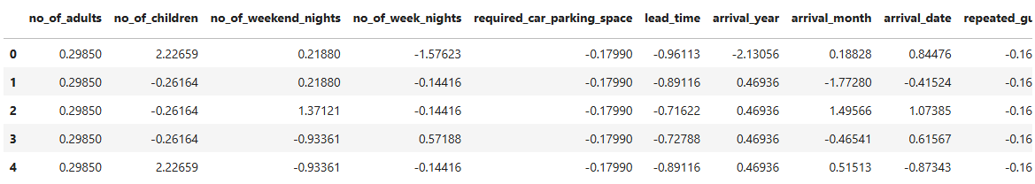
Figure 35: Top 5 Rows of Scaled Test data

8.2 Logistic Regression (with Statsmodel)
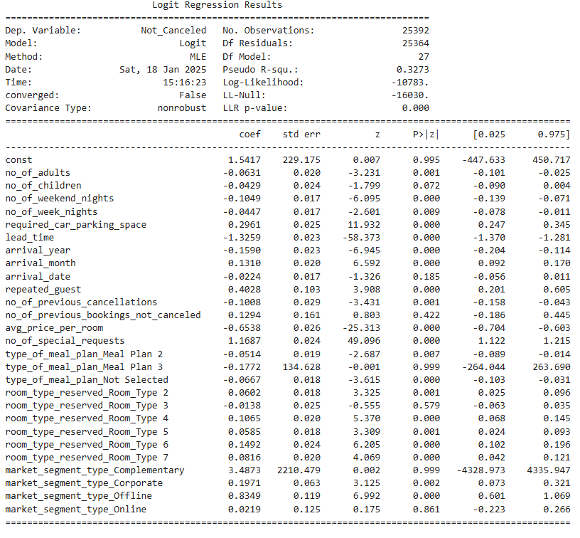
Figure 36: Logistic Regression (with Statsmodel)

8.2.1 Checking Logistic Regression model performance on training set
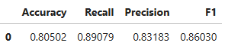
Figure 37: Performance of model on Training set
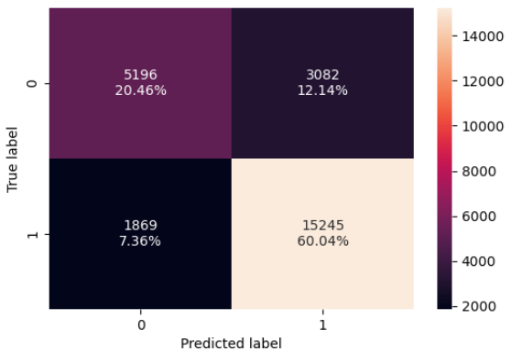
Figure 38: Confusion Matrix

8.2.1 Checking Logistic Regression model performance on test set
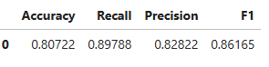
Figure 39: Performance of model on test set
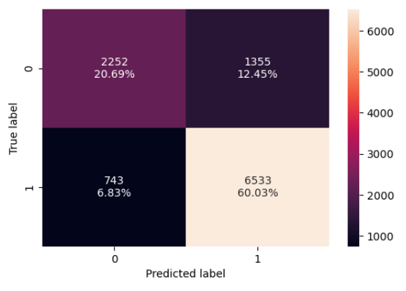
Figure 40: Confusion matrix

8.3 Naive - Bayes Classifier

8.3.1 Checking Naive - Bayes Classifier performance on training set
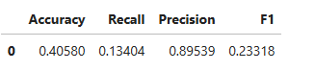
Figure 41: Performance of model on train data

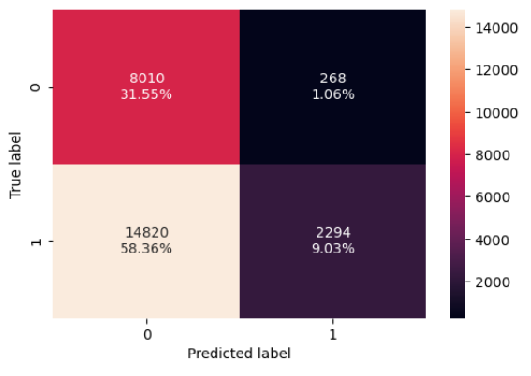
Figure 42: Confusion matrix

8.3.2 Checking Naive - Bayes Classifier performance on test set
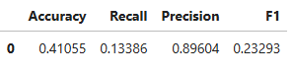
Figure 43: Performance of model on test set
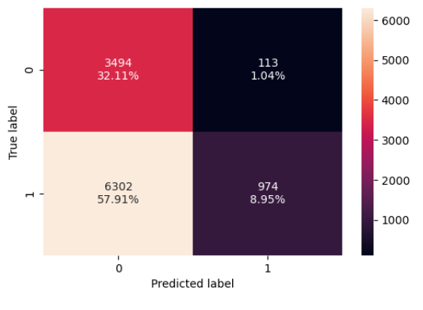
Figure 44: Confusion matrix

8.4 KNN Classifier (K = 3)

8.4.1 Checking KNN Classifier performance on training set
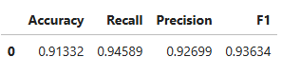
Figure 45: Performance of model on training set
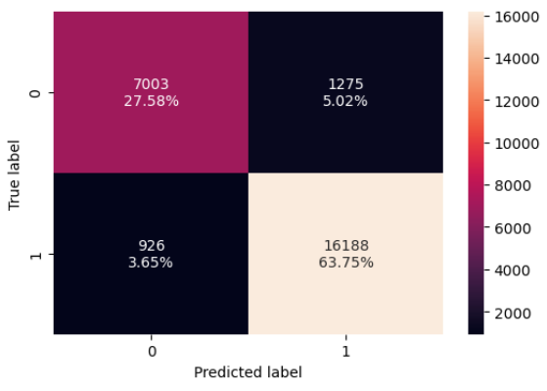
Figure 46: Confusion Matrix

8.4.2 Checking KNN Classifier performance on test set
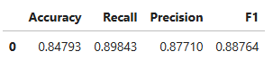
Figure 47: Performance on test set
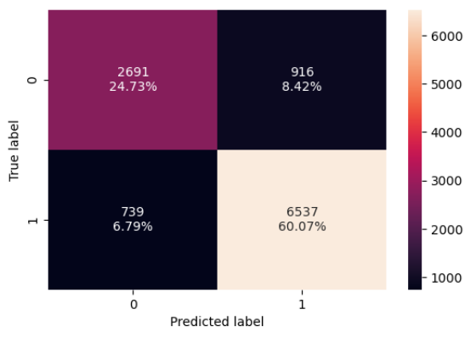
Figure 48: Confusion Matrix

8.5 Decision Tree Classifier

8.5.1 Checking Decision Tree Classifier performance on training set
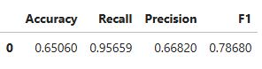
Figure 49: Performance of model on training set
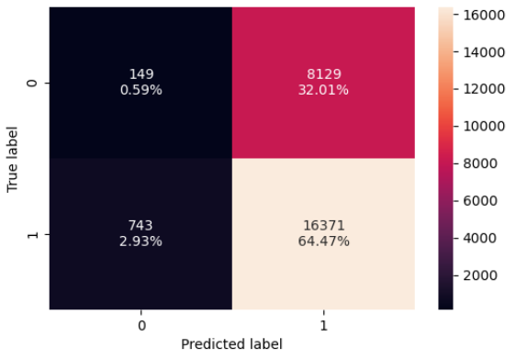
Figure 50: Confusion matrix

8.5.2 Checking Decision Tree Classifier performance on test set
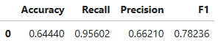
Figure 51: Performance of model on test set
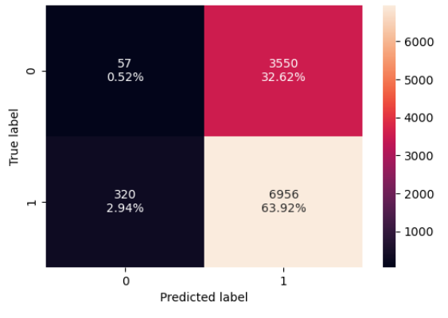
Figure 52: Confusion matrix

9.0 Model Performance Improvement
Logistic Regression (deal with multicollinearity, remove high p-value variables, determine optimal threshold using ROC curve)
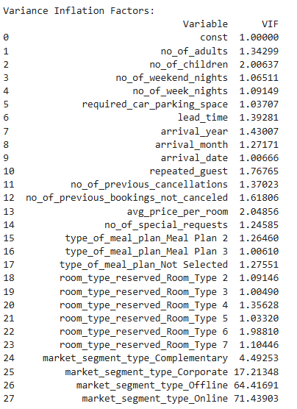
Figure 53: Attributes
Dropping columns with VIF > 5 iteratively
Figure 54: Dropped Attribute
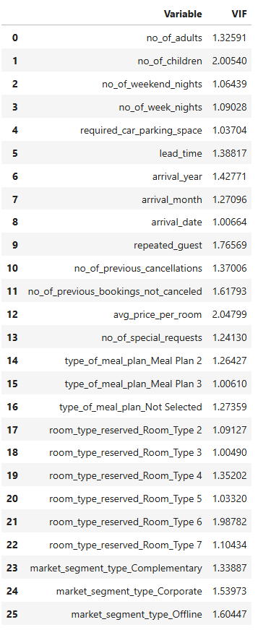
Figure 55: Attributes and their VIFs

9.1 Dealing with high p-value variables
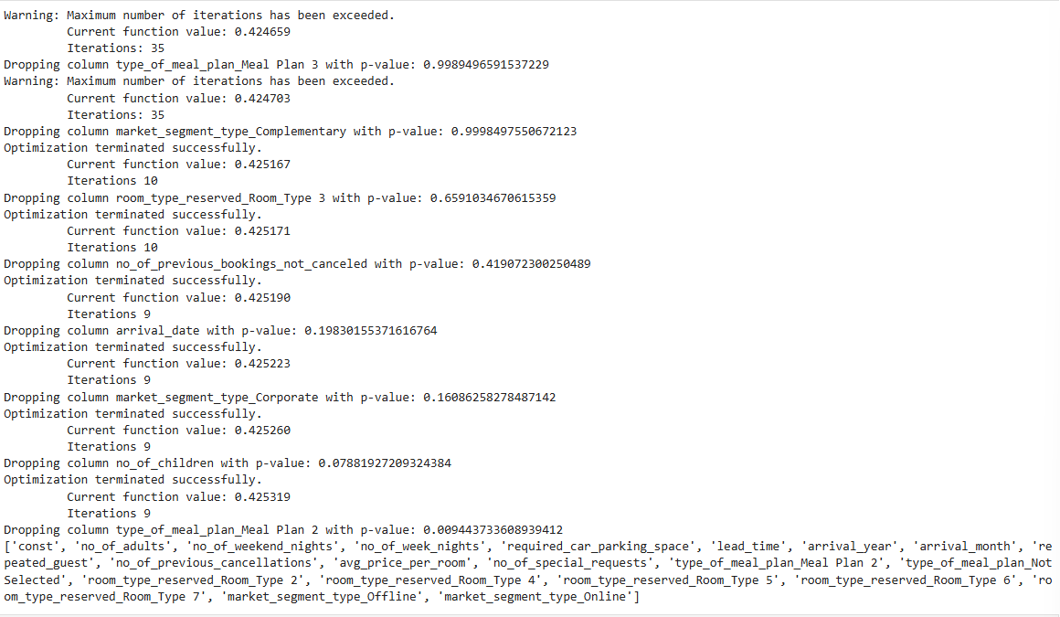
Figure 56: P-value of the variables

After dropping variables with high p-value variables and here are the significant variables.
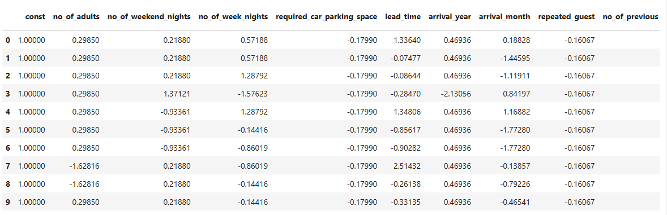
Figure 57: Significant variables

9.2 Training the Logistic Regression model again with only the significant features
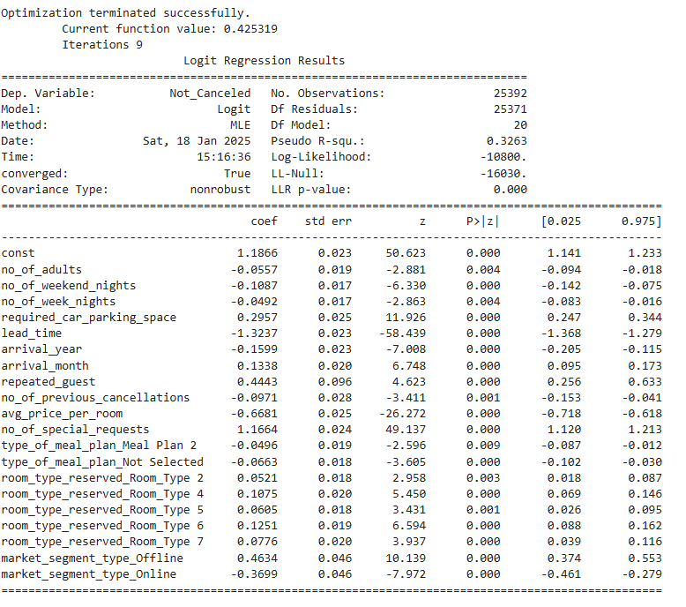
Figure 58: Logistic model summary after tuning

9.3 Determining optimal threshold using ROC Curve
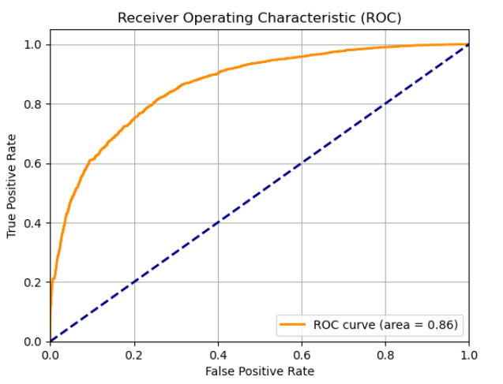
Figure 59: ROC Curve
the ROC curve analysis indicates a well-performing model, and the AUC of 0.86 reflects its reliability in classification tasks.
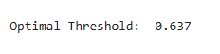
Figure 60: Optimal Threshold

9.4 Checking tuned Logistic Regression model performance on training set.
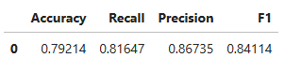
Figure 61: Performance of Logistic Regression model on Training set
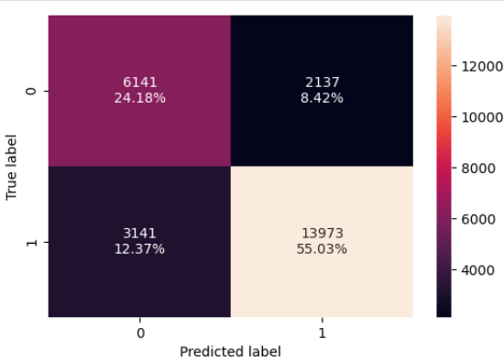
Figure 62:Confusion Matrix

9.5 Checking tuned Logistic Regression model performance on test set.
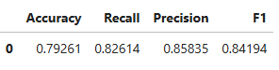
Figure 63: Performance of tuned model on test set
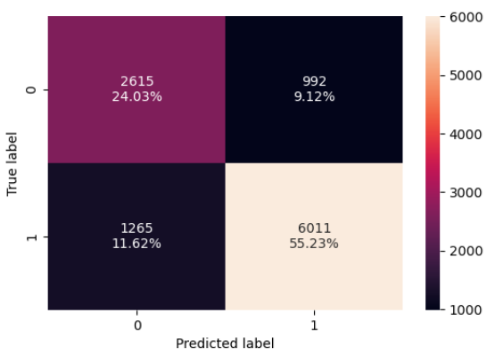
Figure 64: Confusion matrix

9.6 KNN Classifier (different values of K)

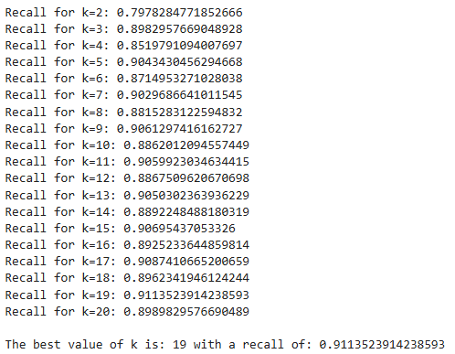
Figure 65: KNN Classifier with different K values

9.7 Checking tuned KNN model performance on training set.
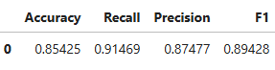
Figure 66: Model performance on train set
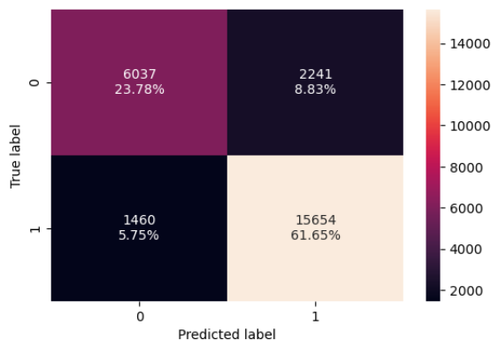
Figure 67: Confusion matrix

9.8 Checking tuned KNN model performance on test set.
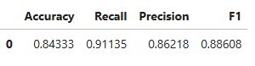
Figure 68: Model performance on test set
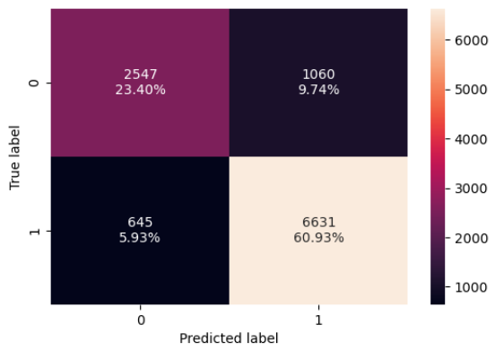
Figure 69: Confusion Matrix

9.9 Decision Tree Classifier (pre-pruning)

Max_depth = 11
Max_leaf_nodes =100
Min_samples_split = 30
Random_state = 42

9.10 Checking tuned Decision Tree Classifier performance on training set
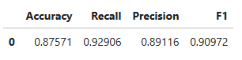
Figure 70: Model performance on train set
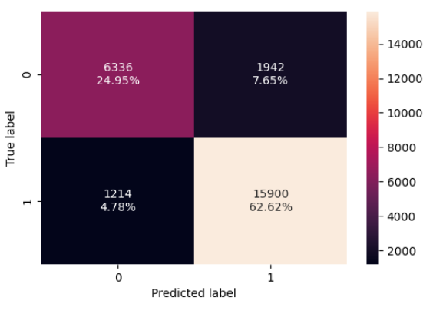
Figure 71: Confusion Matrix

9.11 Checking tuned Decision Tree Classifier performance on test set
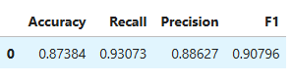
Figure 72: Model Performance on test set
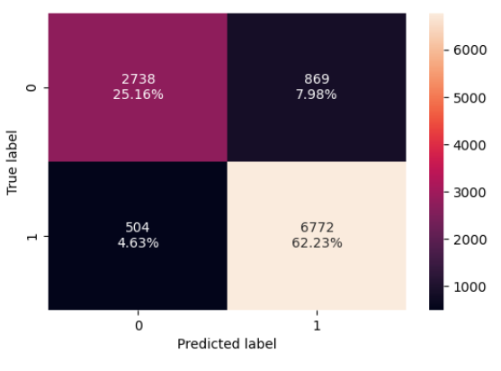
Figure 73: Confusion Matrix

9.12 Visualizing the Decision Tree
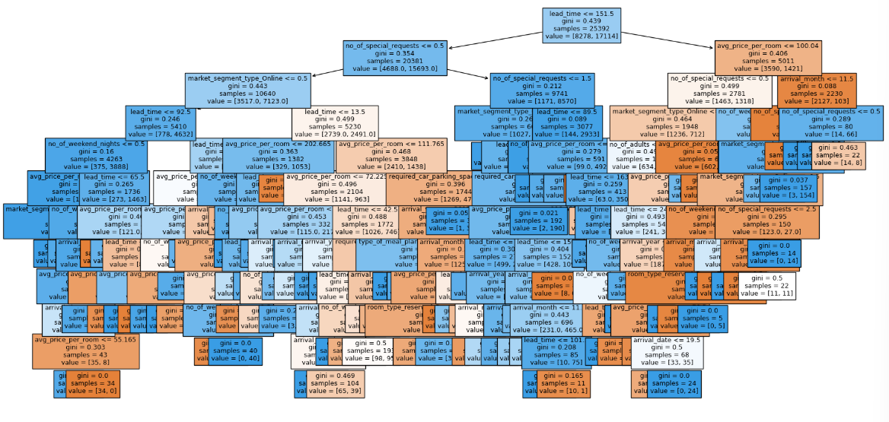
Figure 74: Visualizing the Decision Tree

9.12 Analysing Feature Importance for tuned Decision Tree Classifier
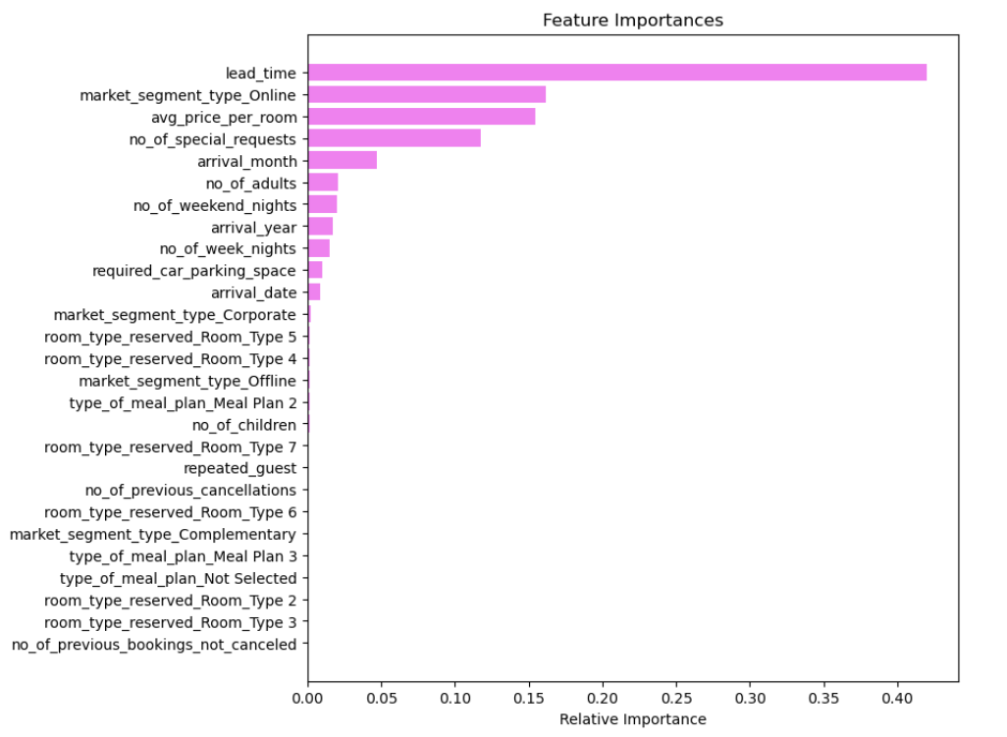
Figure 75: Feature Importance for tuned Decision Tree Classifier

10.0 Model Performance Comparison and Final Model Selection
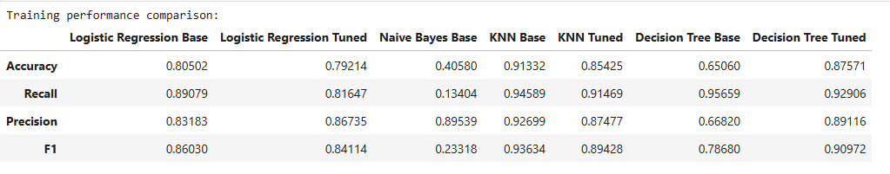
Figure 76: Model Performance Comparison and Final Model Selection on train set

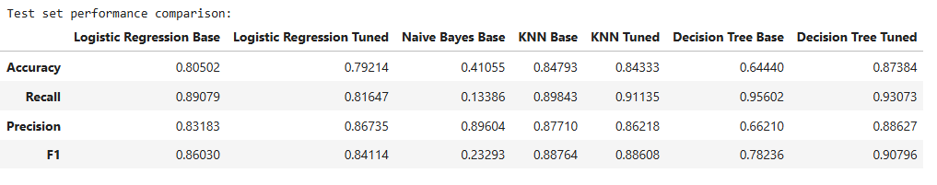
Figure 77: Model Performance Comparison and Final Model Selection on test set

Decision Tree Tuned is the best model. As comparing with other models its performing well on this model.

11.0 Actionable Insights and Recommendations
Actionable Insights:
Lead Time:
Insight: Longer lead times significantly increase the likelihood of cancellations.
Recommendation: Consider implementing stricter cancellation policies for bookings made well in advance. For example, require a non-refundable deposit for long lead-time bookings.
Market Segment Type (Online):
Insight: Bookings made through online channels have a higher likelihood of cancellation.
Recommendation: Offer incentives such as discounts or loyalty points for customers who book directly through the hotel's website or app. This can help reduce dependency on third-party platforms and potentially lower cancellation rates.
Average Price per Room:
Insight: Higher-priced rooms are more likely to be cancelled.
Recommendation: Implement flexible pricing strategies to encourage customers to commit to their reservations. For example, offer special non-refundable rates with discounts for higher-priced rooms.
Number of Special Requests:
Insight: Guests who make multiple special requests are more likely to cancel.
Recommendation: Track and review special requests to identify patterns and trends. Consider reaching out to these guests with personalized communication to confirm their reservations and address their needs.
Recommendations:
Implement Tiered Cancellation Policies:
Develop tiered cancellation policies based on booking characteristics such as lead time, room type, and booking channel. For example, offer flexible cancellation options for last-minute bookings but enforce stricter policies for long lead-time bookings.
Optimize Distribution Channels:
Analyse the performance of various distribution channels and optimize the mix to reduce cancellations. Prioritize channels that have lower cancellation rates and offer incentives for direct bookings.

Enhance Customer Communication:
Improve pre-stay communication with guests to reduce cancellations. Send reminders, special offers, and personalized messages to keep guests engaged and committed to their reservations.
Offer Incentives for Non-Cancellation:
Introduce loyalty programs or incentives for guests who honour their bookings. Offer discounts, loyalty points, or other rewards for guests who consistently avoid cancellations.
Monitor and Adjust Pricing Strategies:
Use dynamic pricing strategies to adjust room rates based on booking patterns and cancellation likelihood. Offer special non-refundable rates or discounts for guests who are less likely to cancel.
Review and Refine Special Requests Management:
Monitor special requests closely and identify guests with high cancellation risk. Offer personalized services and communication to address their needs and reduce the likelihood of cancellations.
By implementing these insights and recommendations, INN Hotels Group can proactively manage booking cancellations, optimize their revenue, and improve guest satisfaction.

12.0 Answers to EDA questions

What are the busiest months in the hotel?

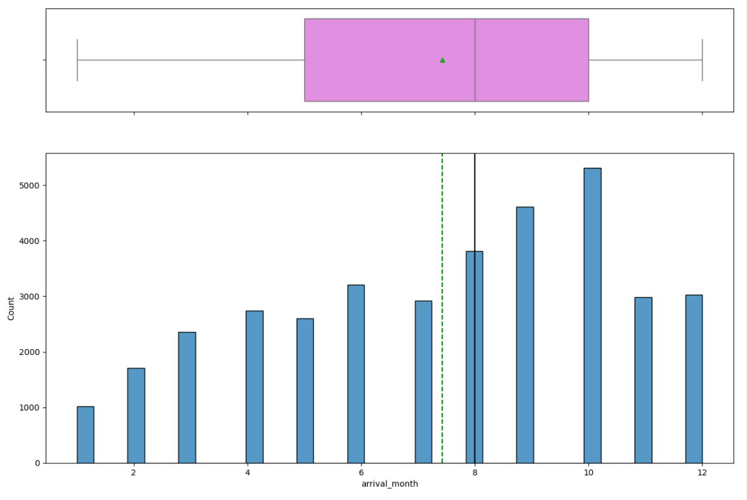
- Most of the bookings are in Month of October, September, and August. One can say these are the busiest months in the hotel.

Which market segment do most of the guests come from?
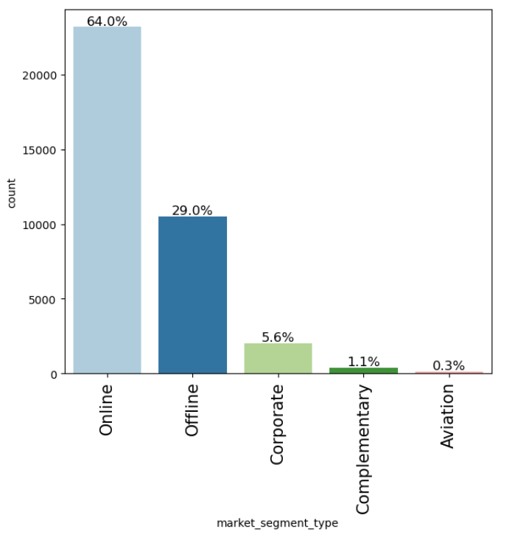

- Most of the bookings are of Online, then Offline.

Hotel rates are dynamic and change according to demand and customer demographics. What are the differences in room prices in different market segments?
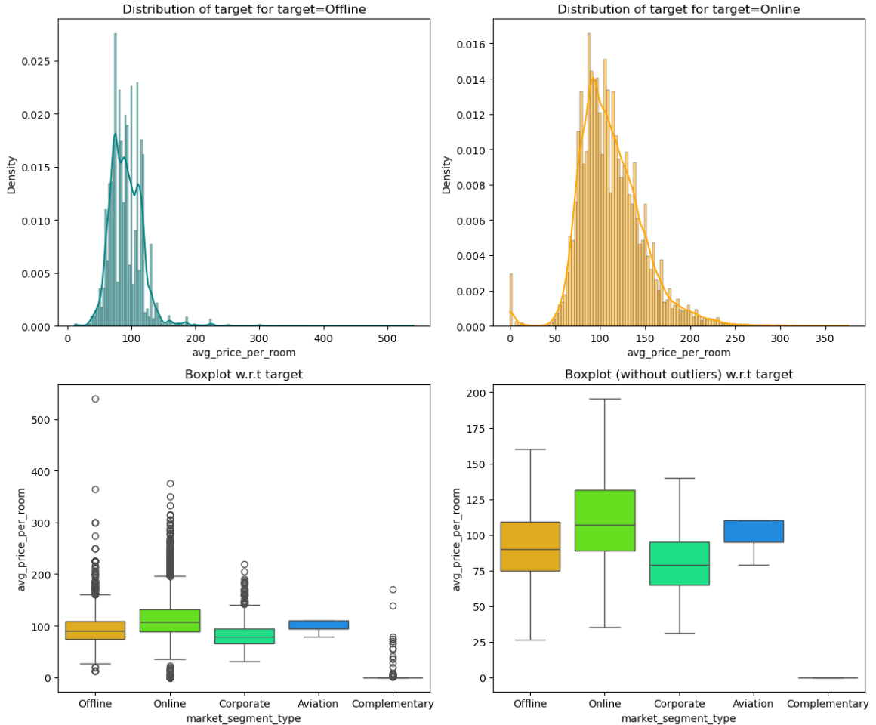
- Avg. Price of Online Market Segment is high compared to other segments.

What percentage of bookings are cancelled?
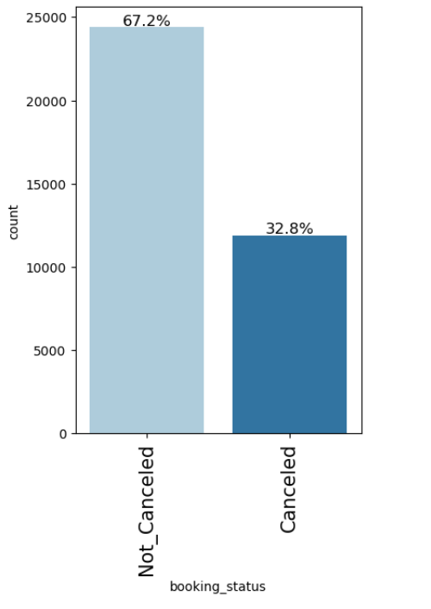
- 32.8% of bookings are cancelled.

Repeating guests are the guests who stay in the hotel often and are important to brand equity. What percentage of repeating guests cancel?
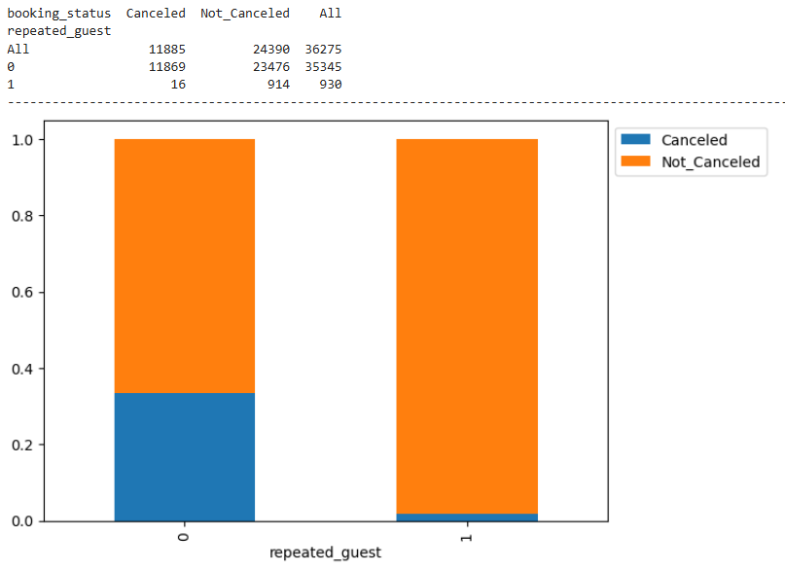

6.0 Many guests have special requirements when booking a hotel room. Do these requirements affect booking cancellation?
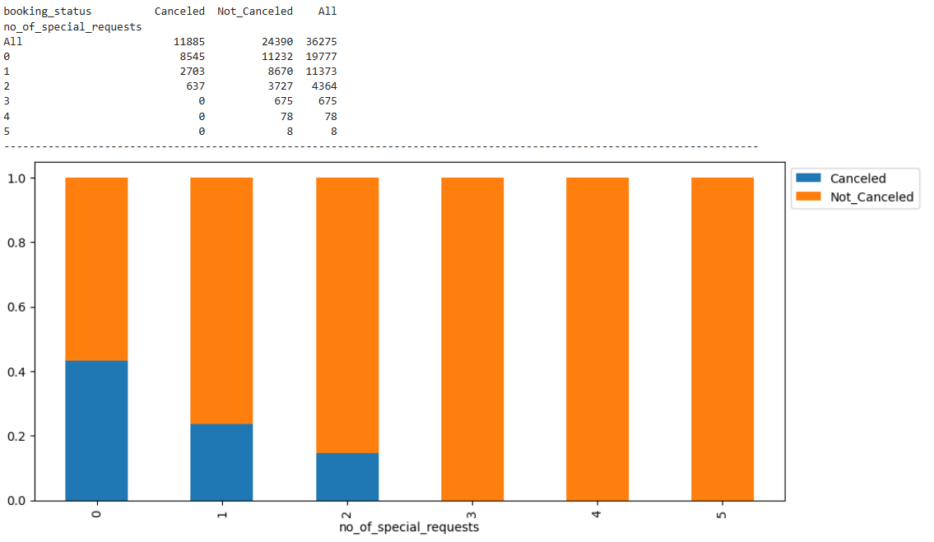
Yes. Requirements affect booking cancellation.

